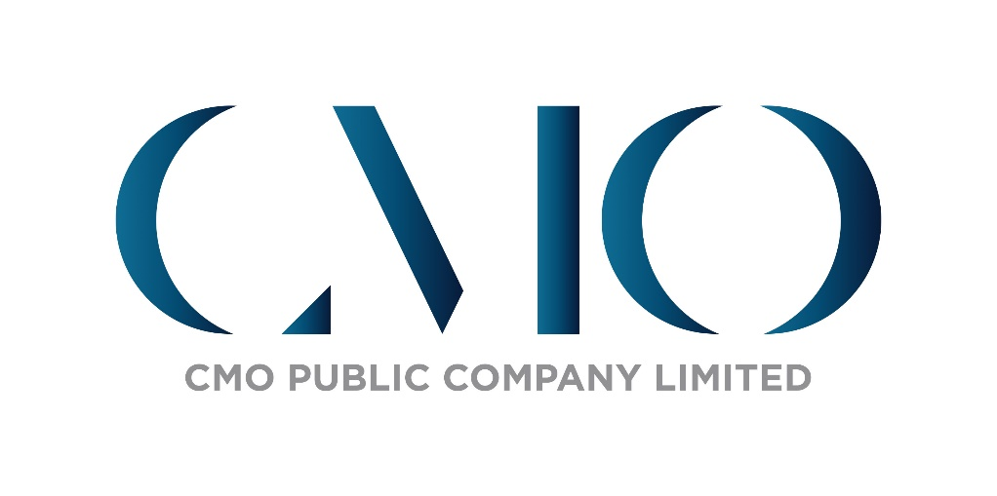

**CMO Public Company Limited**

**Risk Management Policy**

**Risk Management**

CMO Group Public Company Limited focuses on the importance of risk management. Thus, a risk management system is applied in the Company by reference to the framework of COSO (The Committee of Sponsoring Organizations of the Treadway Commission), which is the International Standard. The Board of Directors has assigned the Audit Committee to review the Company’s performance to efficiently and effectively organize and manage risk. The Internal Audit Department is responsible for inspecting to ensure that the operational department has an adequate internal risk management system and reporting to the Audit Committee. In addition, the Internal Audit Department also provides consultations to auditees and communicates feedback for further improvement. Monthly, the Company had a management meeting on risk management among business units to prepare to handle and prevent any risk that may occur.

**Risk Factors for the Company’s Business Operation**

**1. Risk for the Company’s Business Operation**

**1.1 Risk from Social, Economic Instability and the Change of Government Policy**

Event Management is connected to and related to advertisement and public relations business that directly ties in with the country's overall economic situation. Public spending and general business survival are essential factors for product or service owners in considering any advertisement or public relations, which include exhibitions as a marketing tool for sales promotion.

When people in the country, ranging from business sectors at the level of consumer product operators to the high impact level such as energy, are substantially sensitive to the political situation. Therefore, the business operation is directly affected by overall political and economic movements such as political stability, political protest, and monetary policy. These factors affect the consideration of roles of advertising, public relations, and budget for organizing event activities, not to mention various project policies established and supported directly by the government and jointly promoted by the private sector. Examples are gigantic projects of event organizations, such as the country’s public relations projects for tourism purposes or international conferences. It may be changing the projects’ policy to conform with current circumstances.

Nevertheless, the Company has always been well-prepared for such cases. The Company attempts to allocate the management to avoid over-reliance on certain parties from the government or private sector. The company revenue comes from different customers, not depending on or influenced by any customer. It also tries to balance income-generating operations with maximum prudence, from establishing the policy to relying on its work. Recently, Thailand has been the Center of an International Conference. This cause gave the Company get opportunities to organize International Conference projects. Also, the Company aims to get more revenue from these opportunities. So, the Company has set up a new International Meeting and Conference business.Moreover, Company has CLMV's policy to expand the business to CLMV's and ASEAN countries by using Company's advantages and strong points.

In addition, over the past three years, Thailand's economy and the world have been significantly affected by the Coronavirus (COVID-19) pandemic. Economic activities were directly affected, especially tourism, due to the measures to limit traveling into and out of the country. On the other hand, domestic consumption also shrunk. However, the Company was well aware of the risks, as mentioned earlier, thereby conducting an initial risk evaluation and setting the operating cost management policy to reduce overall expenses to maintain the cash flow of the Company able to continue the business.

**1.2 Emerging Risks from Changing that may affect the Company's Business Operations in the next 3-5 years and advances in Technology**

An advantage of today’s technology is beyond bounder. Trends or lifestyles in the west end can cross or share via the internet to be popular on another side of the continent overnight. All of these can happen because of the advantage of technology, which changes very fast. According to COVID-19, the pandemic will become an accelerator that drives trends that once were believed would take years to rise. Then, creating a new consumer experience cannot be used traditional way anymore. The company always combines trends and technology in company events to deliver clients’ experiences.

The company has developed and encouraged the quality of events to go even further. With the exposure to new technologies corresponding to the event, there is a team to take care of customers and give advice closely. Ready to create quality events from new perspectives. They are always beneficial to the business of the customer's company, such as finding new marketing tools or creating cooperation with the owner of that technology. To work together and transfer knowledge that helps strengthen the company's business units continually.

In addition to events, the company plans to deal with technological changes. By studying the establishment of a business unit specializing in technology to design, develop and bring technology currently available. To provide services in various fields to strengthen customers' confidence that they receive efficient and modern services at all times. Including different application development plans that will be able to meet the needs of all groups of customers shortly.

**1.3 Risk from Uncertainty of the Customer Marketing Plan and Changing Consumer Behavior**

The world has been rapidly changing over the past three years due to The COVID-19 pandemic. Without any doubt, it significantly impacts household consumption and business operation. COVID-19 also results in the cessation of on-ground events, which is an efficient tool of marketing to penetrate the target customer of each product or service. Consequently, the Company and our affiliations could be easily affected by the risk of changing the customer marketing plan.

COVID-19 will change consumer behavior to be more internet-based. Nowadays, Online platform is taking an important role and also rapidly growing. Therefore, the company has developed both online and hybrid Events to meet customer needs. As a result, our live-streaming studio has been constructed to launch online events and a new virtual experience. These can make our clients easily reach their customers.

Moreover, since the Company has been in the business continuously for over three decades, it has a customer base comprising both government and private sectors conducting various types of business, which has a different period of setting events in a year. These could help Company to minimize the risk. Moreover, Company also has a policy to reach new clients in all parts of industries, such as Museum management and construction, which is getting fewer effects from the pandemic, for revenue growth and palliative effect when key accounts abstain from an event. The company has a business unit to care for and closely provide customer services. To embrace all opinions and truly understand the purpose of using customers' budgets. And to evaluate the efficiency of the work that provides services to customers in order to provide high-quality work and achieve maximum satisfaction. It can continue to expand the business continuously

**1.4** Risk from Changing in Operating Industry

Nowadays, the Event Management market has become well-known and has increased market value yearly, not to mention its attractive revenue. Therefore, many operators, including those previously related to the business, which are advertising agencies, media, television programs, and public relations companies, begin to adjust them and find ways to create more revenue from the event management market. These operators attempt to focus on their existing strengths, as well as to incorporate the business of event management into their operations. However, despite the attempt to create more selling points to increase revenue, expertise in event management depends on experience and specific skills. Although these companies try to establish an Event Management division or use other marketing methods to decrease their cost, the expertise of existing personnel still needs to respond to the client's needs. Moreover, they cannot organize the events with equitable standards compared to companies with direct experience in this field. Nevertheless, the growth trend of these companies in the event market still creates pressure and results in more aggressive competition in the industry.

Additionally, the event market involves the movement of previous operators or clients who have accumulated experience and learned about event management from our Company or other event management companies. Therefore, these operators or clients can adjust themselves and learn to organize the events without depending upon direct event management companies in some cases. Thus, the Event industry not only confronts higher competition but also needs to adjust, maintain, and improve its quality. At the same time, it is also necessary to obtain client acceptance from successful performance and to continuously develop its potential to the greatest extent.

The Company has developed and encouraged the quality of event management by accepting new technology suitable for organizing events. Our staff are assigned to take good care of the clients closely and can create high-quality events with new concepts that are always beneficial for the business of the Company. Examples include finding joint ventures to enhance the Company's potential or finding new marketing tools to reinforce the business units continuously. Moreover, the Company takes advantage of the Company's strength by expanding the business into the potential international market to reduce the risks.

**1.5 Risk of Personnel Loss**

The Company attaches great importance to personnel because Event management is a service that uses personnel as the main factor in business operations. That's why the Company could risk losing skilled personnel to competitors in the same industry or customers who need personnel to organize events in-house. Therefore, the Company attempted to reduce such risk by developing associates' abilities and skills and promoting all levels for mutual benefit. Furthermore, the Company paid attention to associates, providing them with good welfare, arranged various projects to build their happiness and job stability, and created good engagement between associates. In addition, the Company has implemented information systems to make the work management efficient.

**1.6 Risk of Human Error**

The Company has strict control policies over its operations. However, accidents may occur during the event, significantly affecting the Company and customers. So the Company has given importance to such matters by setting strict work procedures and inspections by the heads of departments responsible for each job, including the selection of contractors with high standards of work and security. Moreover, if there are many participants, insurance will be provided to reduce the burden of liability in the event of an accident.

**1.7 Risk of Natural Disasters**

Nowadays, the environment and climate are changing and challenging to forecast. Natural disasters occur more often than in the past, which may affect the Company’s business. The event might have to postpone avoiding these disasters.

The Company is always concerned and does monitoring the situation both natural disasters and other situations, both inside and outside of the country closely, especially in areas where the Company will be held to find a way to prevent any problem that may occur as well as the safety of those who will be in attendance.

The Company is also concerned about the safety of staff and audiences. Therefore, the Company will provide third-party insurance for audiences who participated in the event in case of public events and events that the Company considered. In addition, a part of the operation in the Company also has the plan to handle natural disasters, such as the management of IT Infrastructure that is a data safety in the computer system from any disasters to maintain the core data of the Company to continue the flow of work.

**1.8 Risk of Cyber Security**

Presently, digital system and information digital are more involved with business operation, including connecting with equipment and parts of business via the Internet. As a result, business operations are vulnerable to cyber threats such as theft of commercial data and personal information that may affect the Company’s’ reputation and reliability. Therefore, to manage and reduce such risks, the Company has undertaken various actions such as establishing set authorization, Install firewall and threat surveillance systems including staff who monitoring the operation and solve the problem of the system. Also, updating Hardware and Software systems to meet the modern standard in order to handle new types of cybercrimes, perform a penetration Testing and vulnerability assessment to assure the effectiveness of the current system and set the cyber security drill and set disaster recovery plan (DRP) in case of any incident that causes the system to stop functioning. The drill is conducted annually to ensure timely execution if an incident occurs, lessen the damage to the Company’s information system and ensure the continuation of business operation.

**1.9 Risk of Corruption**

The Company is committed to conducting business with transparency, honesty and in accordance with the law and prioritizes moral and ethics in its operation and refuses to tolerate any act that may lead to dishonesty and corruption. The Company has measures to prevent corruption and reduce the risk of corruption within the organization. The measures start with the design and execution of internal control, the creation of moral and values among associates, announcement of supplier code of conduct that have been informed to all stakeholders of the Company. If anyone found the corruption cases, you can whistleblowing or complaints (Whistle Blowing Policy)” as a tool to help the company aware about illegal actions or code of conduct or behaviors that may imply corruption or misconduct by stakeholders of the company.In additional, the company is studying and preparing to participate in the declaration of intention of Thai Private Sector Collective Action Against Corruption (CAC) and sending personnel to attend anti-corruption training courses organized by various institutions so that personnel knows and understand the ethics and are aware of all forms of corruption against including overview of damage from corruption.

**2. Financial Risk**

The nature of Event management business is relevant both of medium to large of customer. Therefore, the Company has to have a large amount of working capital. The financial risk factors are divided into 2 factors as follows:

**2.1 Risk of Accounts Receivable**

A lot of Business Operation was impacted by the spread of coronavirus (Covid-19). Especially cash flow statements that got the risk of receiving payments late, also increasing the credit term that may receive payments late due to the internal arrangements of the customers.

For the Accounts Receivable as of December 31, 2022, amount to 208.84 million baht, which increased from the year 2021, amount 85.60 million baht. Due to the high volume of Event Project in 2022 is close to the normal situation (before the COVID-19 period), almost all accounts receivable are the key customer which has never had overdue payments. Moreover, The Company has regularly assessed the status of each accounts receivable. Moreover, the Company considers that the allowance for doubtful accounts is sufficient and appropriate.

**2.2 Risk of Liabilities**

As of December 31, 2022, the Company has long – term loan with fixed interest charge amount 84.72 million baht. Liabilities was from supporting to businesses affected by the coronavirus (Covid-19) situation according to the Bank of Thailand's announcement which provided a special low interest rate loan. Therefore, it does not affect the management of cash flow and interest expenses of the Company.

**3. Compliance Risk**

**3.1 Personal Data Protection Act 2019 B.E.**

It is the law that sets the rule or regulatory measures regarding the protection of personal information. Regardless of whether the personal information of customers, partners and associates must not be violated. To ensure the legal compliance operation of the company, the company has appointed the personal data protection committee of the organization to have a duty to oversee and prepare various plans by analyzing and improving work process through set policies and practices. This shall be in accordance with the law including strict control to keep personal data of customers, business partners and associates to be safe, stable and transparent in order to comply with the enforcement of the Personal Data Protection Act B.E. 2019.

The company has established various measures to determine the purpose, conditions, notification of consent requests, data collection, and data usage and disclose of personal information to be as required by the law. In addition, the company uses security systems that are of high standards in both technology and processes to prevent data hacking of confidential information and developing personnel at all levels to ensure that the company standardized data security by installing Firewall and intrusion detection software, Data encryption Technology, Scan Virus Software for effective virus protection, determining users’ access right according to the Level of Authorization. Further detailscan be found in the Personal Data Protection Policy on the company’s website.

**3.2 Laws and Regulations of Investing Aboard**

For the year 2023, the Company aim to invest and organize international concert in aboard. Therefore, studying the laws relating to organizing international events in aboard is necessary as well as requiring permission from the relevant government agencies. For the guidelines to prevent problems that will occur, the Company has hired the professional agencies to organize events and apply for permission from relevant government agencies including hiring a legal advisor with expertise in examining contract terms and providing appropriate advice to prevent problems that may arise in the future.

**4. Investment Risk of Securities Holder**

Currently, the Company has the Chairman of the Board and Chief Executive Officer as the same person. However, the structure of the Board of Directors of the Company consist four independent directors out of seven directors, which is more than half of the total of Board of Directors, resulting in the balance of power of the Board. Also, the Audit Committee is consisting of three Independent Directors that each of whom has knowledge and abilities. As such, they can audit the Company’s performance with greater transparency and balance the power regarding to this matters for consideration in the shareholders’ meetings to some extent. Furthermore, the Company has a regulation to handle the case of transactions related to Directors, the major shareholder or people authorized to control the business, as well as people that may have a conflict of interest. This regulation states that these people shall have no authority to approve the transactions, which can reduce potential risks. The Company’s management structure is composed of a total of three committee, namely the Board of Directors, Executive Committee, Audit Committee and the Nomination and Remuneration Committee. Because the roles of the respective committees are clearly delineated, the Company’s work systems are equipped with a good standard and are easy to audit.